RESILIENCE LEADERS MEETING MINUTES

The following are draft minutes for the meeting of the Resilience Leaders held from 9:00 am to 11:00 am on Friday, February 25, 2022, via Zoom, any corrections will be added/corrected later.
- CALL TO ORDER (9:00 AM):
- Kasandra Gandara called the meeting to order. Those present introduced INTRODUCTION- KASANDRA
- Tell us about a path or journey you didn’t take – put in chat

- DISCUSSION ITEMS:
- House Keeping: Need to figure out how to begin having meeting in person/hybrid.

- Update Mini/ Large Summit: Important to read book Adaptive Leadership(see pic below). Have to really think if we can do 2 days. Jolene sent a link for Acumen Academy – Sylvia will send the email if interested in registering.
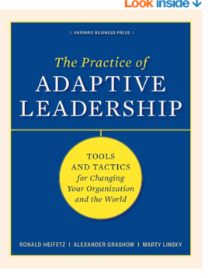

- Other Information –

- Social media platforms: please share with others:
- Website: dacrl.org
- Facebook: @dacresilienceleaders
- Twitter: @resiliencelead1
- Instagram: donaanar4esilience_leaders1

- Sector leaders should all have gotten a jump drive with information
- Budget –We have spent 48,740.52 our balance is 86,081.23.
- Presentation by FYI+ Innovations – contact information : Brianna Dever bdever@fyinm.org 575-647-5639 and Anastasia Zuniga (Anya) azuniga@fyinm.org offer trainings on section education, types of violence & abuse, etc. Can reach out for training days or for power point that was presented.
- Set Next Meeting Date. Friday, March 25, 2022
Adjournment. 1 hour early due to Health fair

